Idaho Weather

**Site Plan**

**Site Name**

This site is going to be called IdahoWeather.com

**Site Purpose**

The IdahoWeather.com site purpose is to inform current residents as well as nonlocal residents of the current weather in Preston, Soda Springs, and Fish Haven. One of the goals for this site is to inform nonlocal residents of the weather in Preston, Soda Springs, and Fish Haven so they can plan their travel to these cities without any concern if the weather is bad.

**Target Audience**

* **Who:** This site will target nonlocal residents that wants to visit these cities.
* **Age:** 16-100
* **Income:** None
* **Technology:** Audience can use any device such as, desktop computers, laptops, or smartphone to use the site Idaho Weather.com.

**Personas**



* **Occupation**: Teacher
* **Demographics**: 40 years old. Teacher at a High School. Married with four kids.
* **Goals and motivation for using the site**: Wants to view weather forecast for Preston, Soda Springs, and Fish Haven.



* **Occupation**: Construction
* **Demographics**: 38 years old. Works for a Construction company. Married with three kids.
* **Goals and motivation for using the site**: Wants to view weather forecast for Preston, Soda Springs, and Fish Haven.

**Scenarios**

1. What is the current weather in Preston, Soda Springs, or Fish Haven?
2. What is the weather like next week?
3. Are there any weather alert?
4. What is the month forecast?

**Site Map**

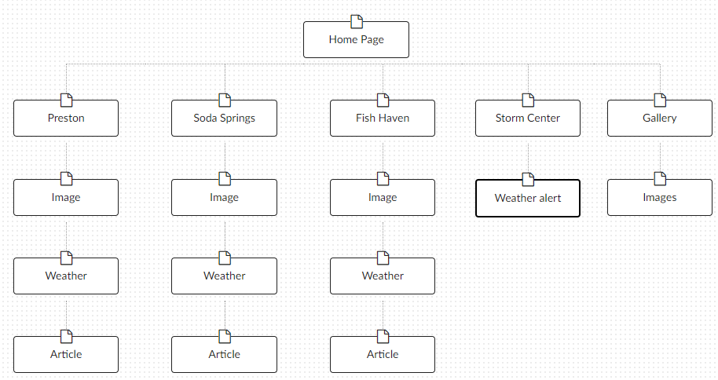

**Style Guide**

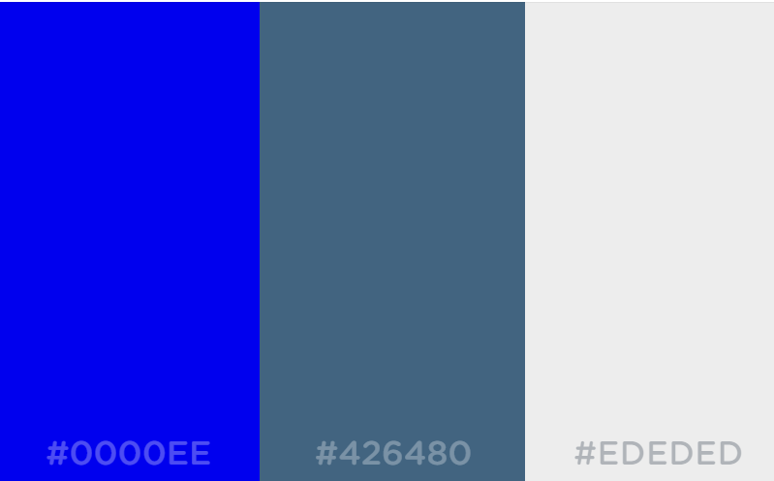**Color Scheme**

Text Background Background

The Background, text of the site.

Primary Color: Blue ##0000FF, Gray #426480 and #EDEDED

**Typography**

Describe the fonts and styles.

**Heading Level 1 (h1)**

Helvetica Weight: Normal Style: Normal

60px

**Heading Level 2 (h2) Arial 20 px#595900**

30px

**Heading Level 3 (h3)**

60px

**Arial Weight:** Normal

**Font:** Arial,

**Font Color**: #0000FF